**DESCRIPTIVE STATISTICS**

**Variable Types**

Numerical or quantitative:-

* **Continuous variable** is also known as ***numerical variable***.
* **Discrete variable** is also known as ***quantitative variable***.

Categorical or qualitative:-

* **Nominal:** Categorical variable which **can’t** be compared to other variables in terms of value (**unordered** categorical variable).
* **Ordinal:** Qualitative variable which **can** be compared to other variables in terms of value (**ordered** categorical variable).

**Descriptive Statistics**

* Describing data through **graphs**, **tables** or other **statistical methods**.
* Takes data from **sample population**.
* There **can** be **multiple variables** involved.

**Graphical Representation**

Single variable:-

* **Categorical variables** can be represented on **categorical graphs**.
* For example, **bar graph**.
* **Quantitative variables** can be represented on **qualitative graphs**.
* For example, ***box plot*** (plotting on scale).

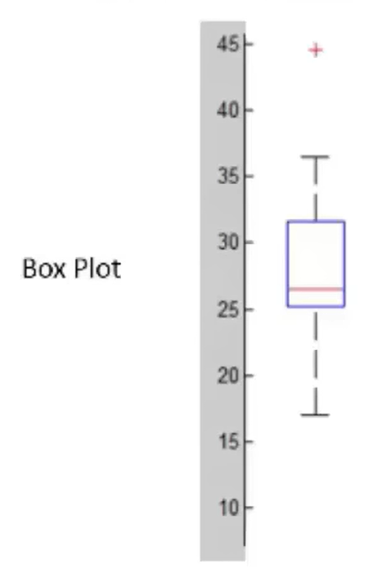

Multiple variables:-

* We use **scatter plots**, **box plots** & **contingency tables**.

